Day-30_Data Structures Coding Challenge
1.STRING Challenge
Problem: Longest Substring Without Repeating Characters
Description:
Given a string, find the length of the longest substring without repeating characters.
Input:
"abcabcbb" 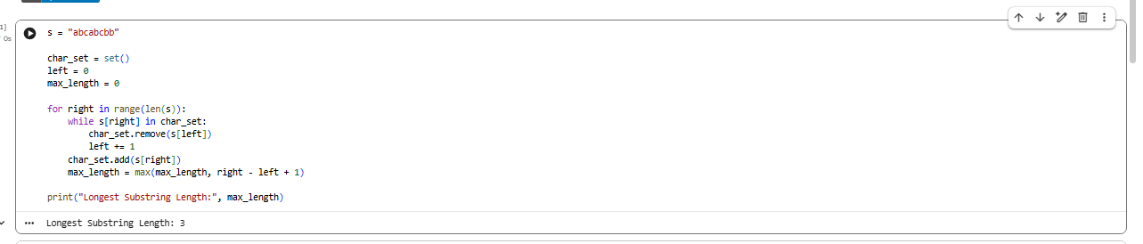
2.LIST Challenge
Problem: Remove Duplicates While Preserving Order
Description:
Given a list of integers, remove duplicates while maintaining the original order.
Input:
[1, 2, 2, 3, 4, 3, 5] 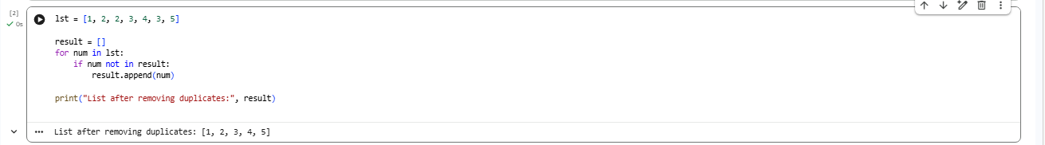
3.TUPLE Challenge
Problem: Find Maximum and Minimum
Description:
Given a tuple of numbers, find the maximum and minimum values.
Input:
(10, 5, 20, 8) 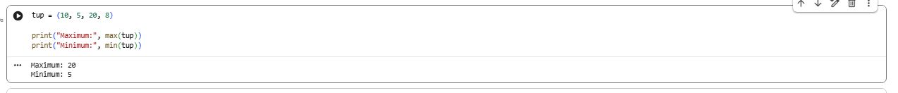
4.DICTIONARY Challenge
Problem: Character Frequency Counter
Description:
Given a string, count the frequency of each character and store it in a dictionary.
Input: "programming" 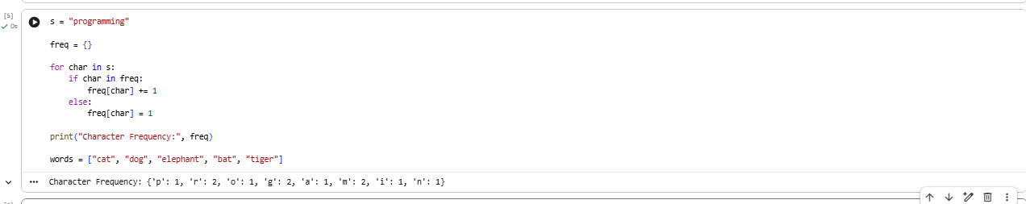
Challenge (Intermediate) Problem: Group Words by Length
Description:
Given a list of words, group them based on their length using a dictionary.
Input:
["cat", "dog", "elephant", "bat", "tiger"]